**Project - 2   
Deploy a Static Website on AWS**

**Table of content**

* Introduction
* Architecture overview
* Folder structure
* Components required
* Step by step guide

**Introduction**

AWS Simple Storage Service (S3) from the aforementioned list, S3, is the object storage service provided by AWS. It is probably the most commonly used, go-to storage service for AWS users given the features like extremely high availability, security, and simple connection to other AWS Services.

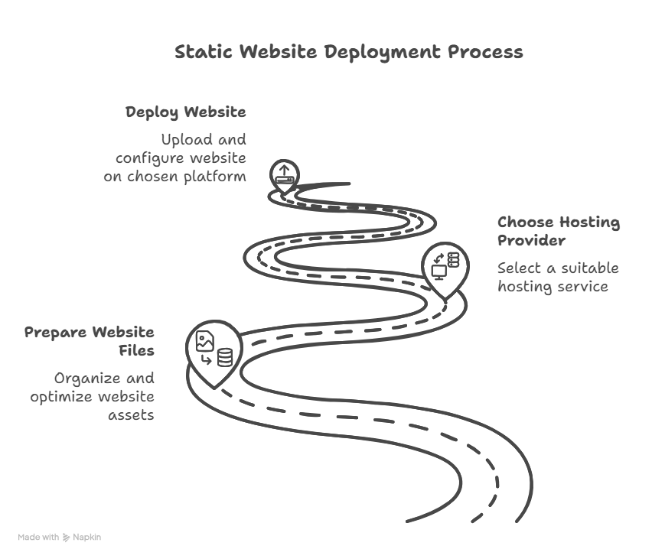**Architecture overview**

**Components required**

In making the static website hosting the components required are :

* Amazon S3 bucket
* Website files
* Static website hosting
* Permission and access

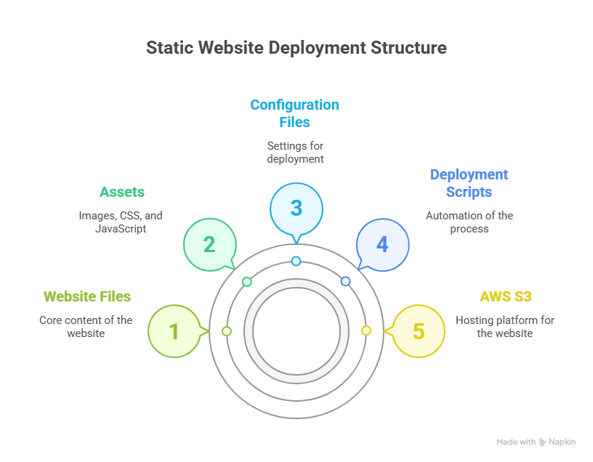**Folder structure**

**Step by step guide**

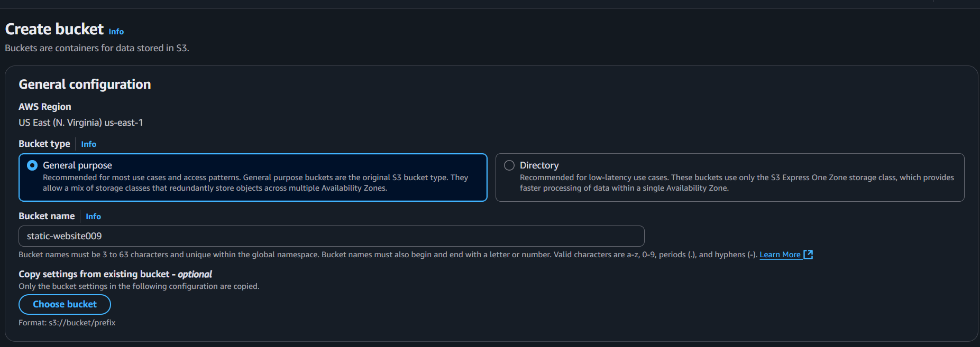**Task-1) Creating s3 bucket**

* 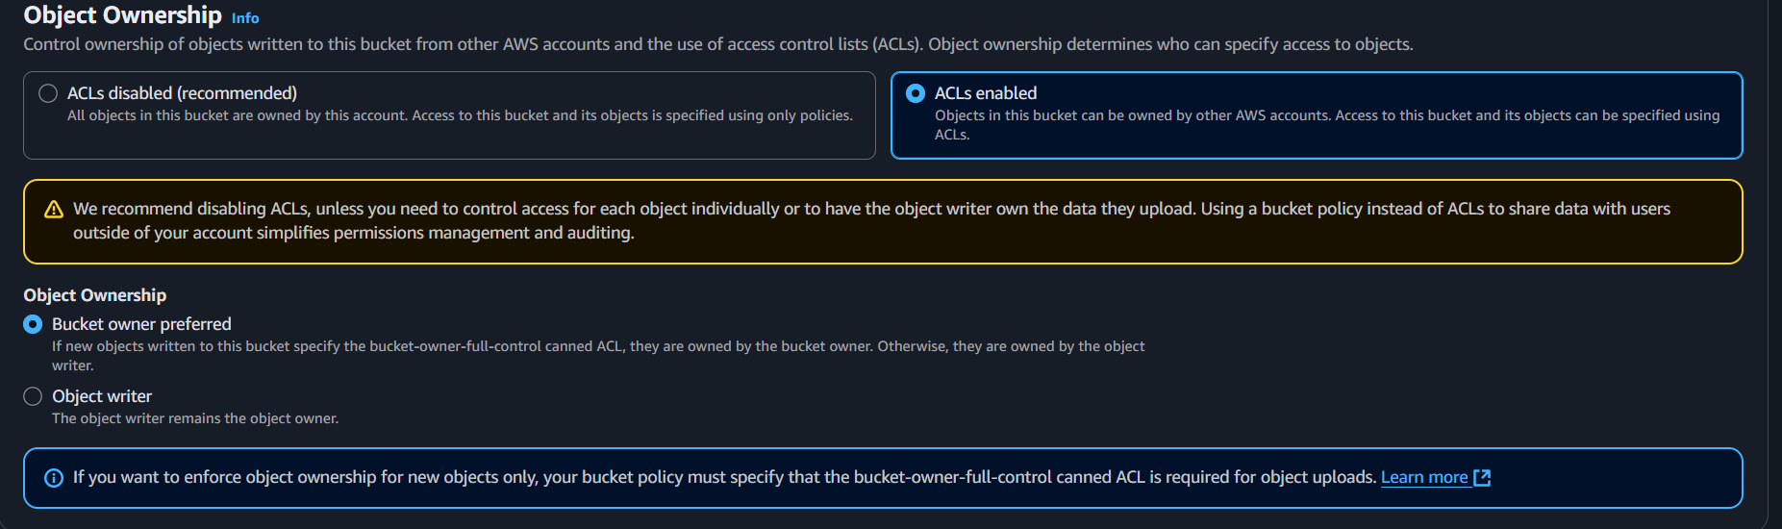we have to enable the ACL.
* 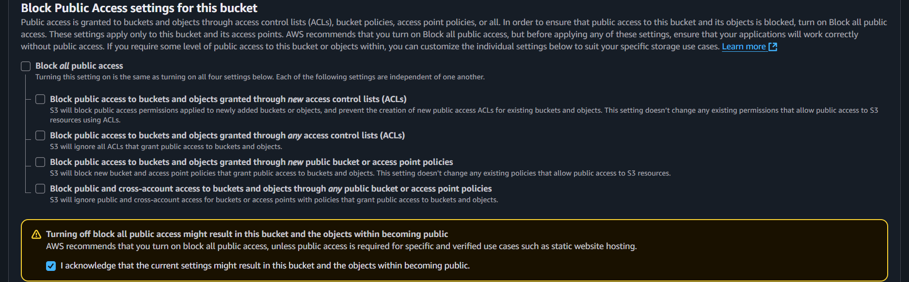 we have to disable the block public access settings .
* click on create bucket.

**Task-2) Adding code files in s3 bucket**

* we have to go to the upload section and upload the code files for the website hosting.

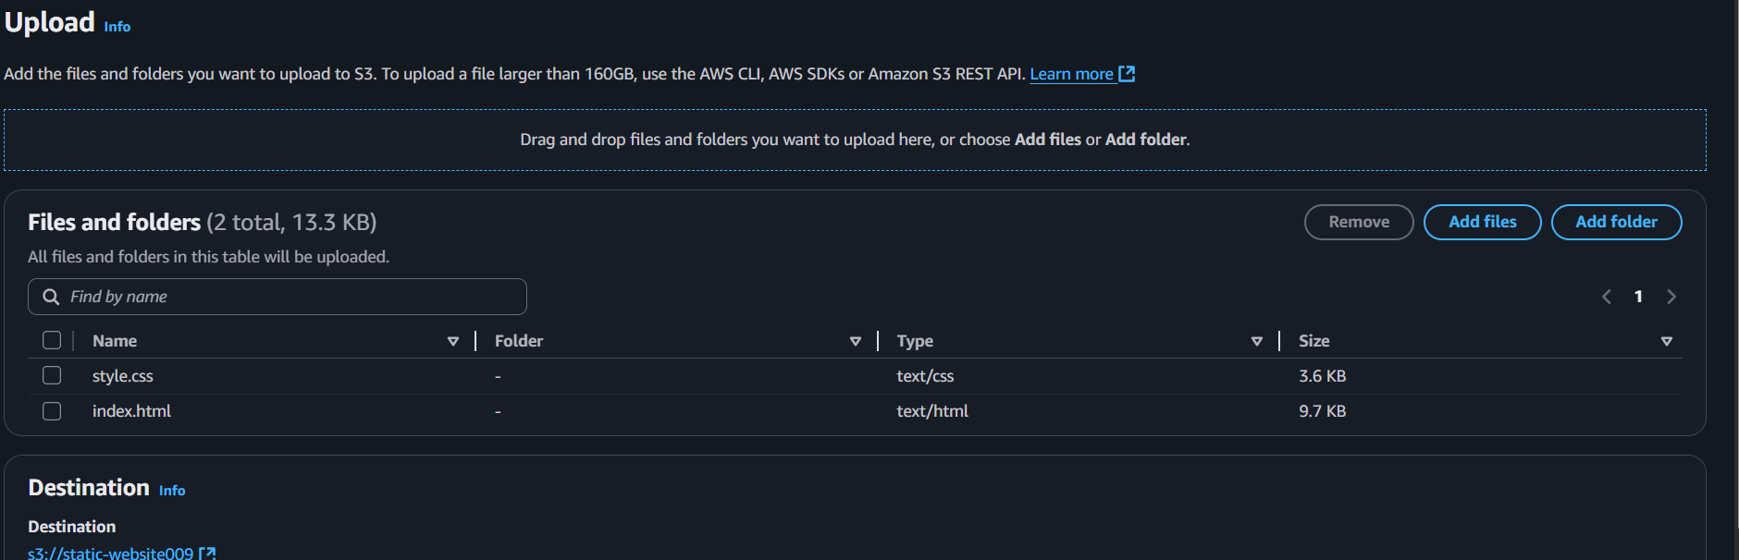

* upload the files successfully.

**Task-3) Enabling static website hosting**

* After uploading the files now go to the properties.
* In properties go to the static website hosting , click on edit.

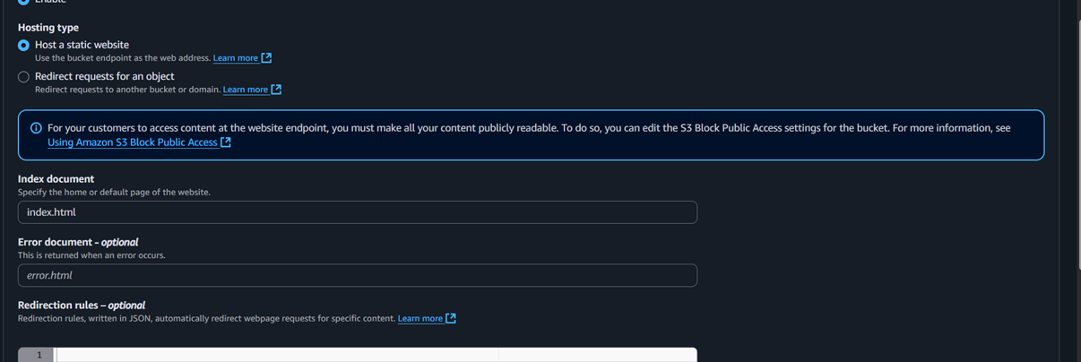

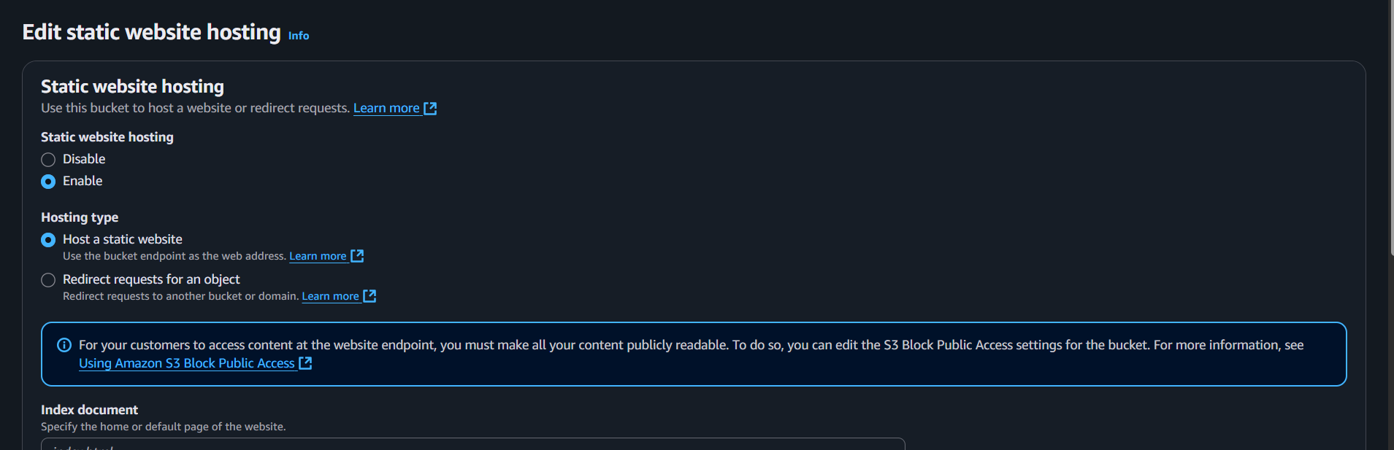

* click on save changes.

**Task-4) Making public using ACL**

* 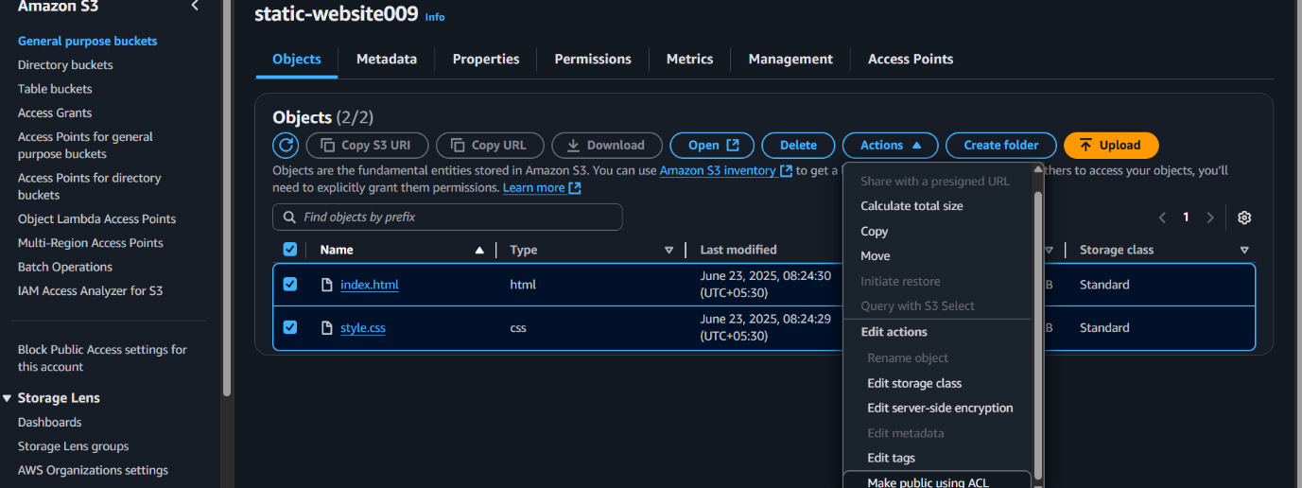In s3 bucket go to actions and choose make public using ACL.
* 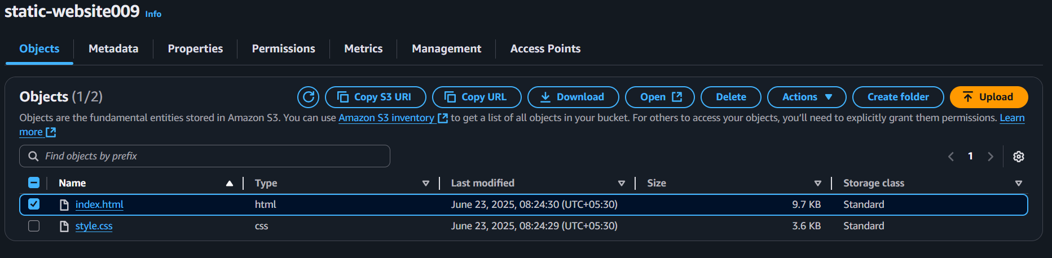now copy the url of your uploaded file.
* paste it in the chrome and website will appear.